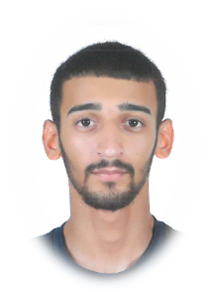 |  | Mohmmed Jaffer A. Wahab
Personal number  970905033  nationality  Bahraini  Date of birth  15 September 1997  martial status  Single  place of birth  Sitra  Contact  PHONE:  35939719  39055452  39805147 |  | EDUCATION  Altawun Secondary School (commercial)  Language knowledge  Arabic  English  SKILLS  Driving  Hobbies  Swimming

